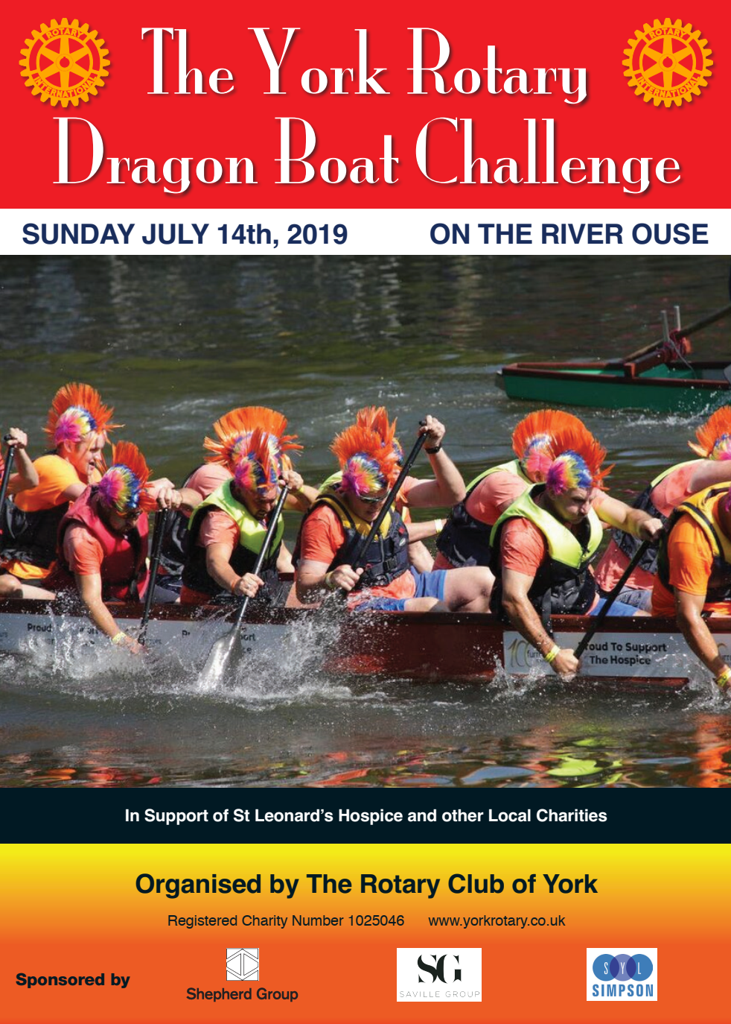

**Organised by The Rotary Club of York**

**Registered Charity Number 1025046** [**www.yorkrotary.co.uk**](http://www.yorkrotary.co.uk)

**Sponsored by**

**PLEASE SUPPORT OUR TEAM**

**by sponsoring us**

**SUNDAY JULY 14TH 2024 ON THE RIVER OUSE**

**In Support of York Samaritans and other Local Charities supported by York Rotary**

**COME AND SUPPORT YOUR TEAM ON THE DAY**